CS 340 README for Grazioso Salvare’s Custom Dashboard

About the Project
This project was developed for Grazioso Salvare, an international rescue animal training organization that identifies and trains dogs for specialized rescue operations. The goal of this dashboard is to allow users to efficiently filter, analyze, and visualize animal shelter data from the Austin Animal Center to identify dogs that meet specific rescue training criteria.
The application follows a full-stack development model using MongoDB as the database (Model), a custom Python CRUD class as the controller layer, and a Dash-based web dashboard as the View. The dashboard allows users to dynamically filter dogs based on rescue type, visualize breed distribution, and view geolocation data for selected animals.
The application includes:
- Interactive rescue-type filtering
- A dynamic and sortable data table
- A geolocation map displaying animal locations
- A breed distribution visualization
- Branding with the Grazioso Salvare logo
- A unique project identifier
The system was designed to be intuitive, reduce user error, and minimize training time for Grazioso Salvare staff.

Component Selection Methodology
The technologies selected for this project were chosen based on flexibility, integration capability, and efficiency.

MongoDB (Model Layer)
MongoDB was selected as the database solution because:
- It supports flexible, schema-less JSON-like document storage.
- It integrates seamlessly with Python via the PyMongo driver.
- It allows efficient querying using structured JSON criteria.
- It is well-suited for handling semi-structured datasets like the Austin Animal Center Outcomes data.
MongoDB allows for dynamic filtering operations, which are critical to rescue-type categorization.

Python CRUD Module (Controller Layer)
A custom CRUD class was implemented to:
- Encapsulate all database interactions
- Provide structured methods for create, read, update, and delete operations
- Separate database logic from the dashboard UI logic
This design improves maintainability and follows MVC best practices.

Dash Framework (View Layer)
Dash was selected because:
- It enables web applications entirely in Python (no JavaScript required)
- It supports reactive callbacks for dynamic updates
- It integrates directly with Plotly for visualizations
- It allows interactive components such as radio buttons and data tables
Dash simplifies full-stack Python-based development while maintaining professional-quality output.

CRUD Class
The AnimalShelter class provides structured database operations using PyMongo. It includes:
- create() – Insert new documents into the collection
- read() – Retrieve records based on query criteria
- update() – Modify records using update filters
- delete() – Remove records from the database
The class securely connects to the MongoDB instance using authenticated credentials. It isolates database logic from presentation logic, improving modularity and scalability.

All filtering operations used by the dashboard are executed through the read() method using dynamic JSON query criteria.

Installation/Pre-Conditions
To use this software, the following tools must be installed:
Python 3.x
MongoDB Server (running locally on port 27017)
JupyterLab (or Codio virtual lab)

Product Walkthrough
Upon launching the dashboard, the user is presented with:
1. The Grazioso Salvare logo and dashboard title.
2. Interactive filter options for:
- Water Rescue
- Mountain/Wilderness Rescue
- Disaster/Individual Tracking
- Reset
3. A dynamic data table displaying animal records.
4. A breed distribution histogram.
5. A geolocation map.

Demonstrate the functionality of your dashboard.
The functionality of the Grazioso Salvare Rescue Dashboard was demonstrated through interactive testing and screenshot documentation.
When the dashboard launches, the Reset filter loads the complete dataset from MongoDB into the interactive data table. This confirms successful database connectivity and CRUD read operations.
Selecting each rescue type filter triggers a Dash callback that performs the following:
1. Executes a MongoDB query using the CRUD module.
2. Filters records based on breed and age criteria (≤ 104 weeks).
3. Updates the data table dynamically.
4. Regenerates the Breed Distribution histogram to reflect the filtered dataset.
5. Updates the Leaflet map to display the selected animal’s geographic location.

The following filter states were tested and documented:
- Water Rescue
- Mountain / Wilderness Rescue
- Disaster / Individual Tracking
- Reset (returns to full dataset)
Each screenshot confirms that all dashboard components (filters, table, chart, and map) update in real time based on user input. This demonstrates proper integration of the Model (MongoDB), Controller (CRUD module and callbacks), and View (Dash interface).

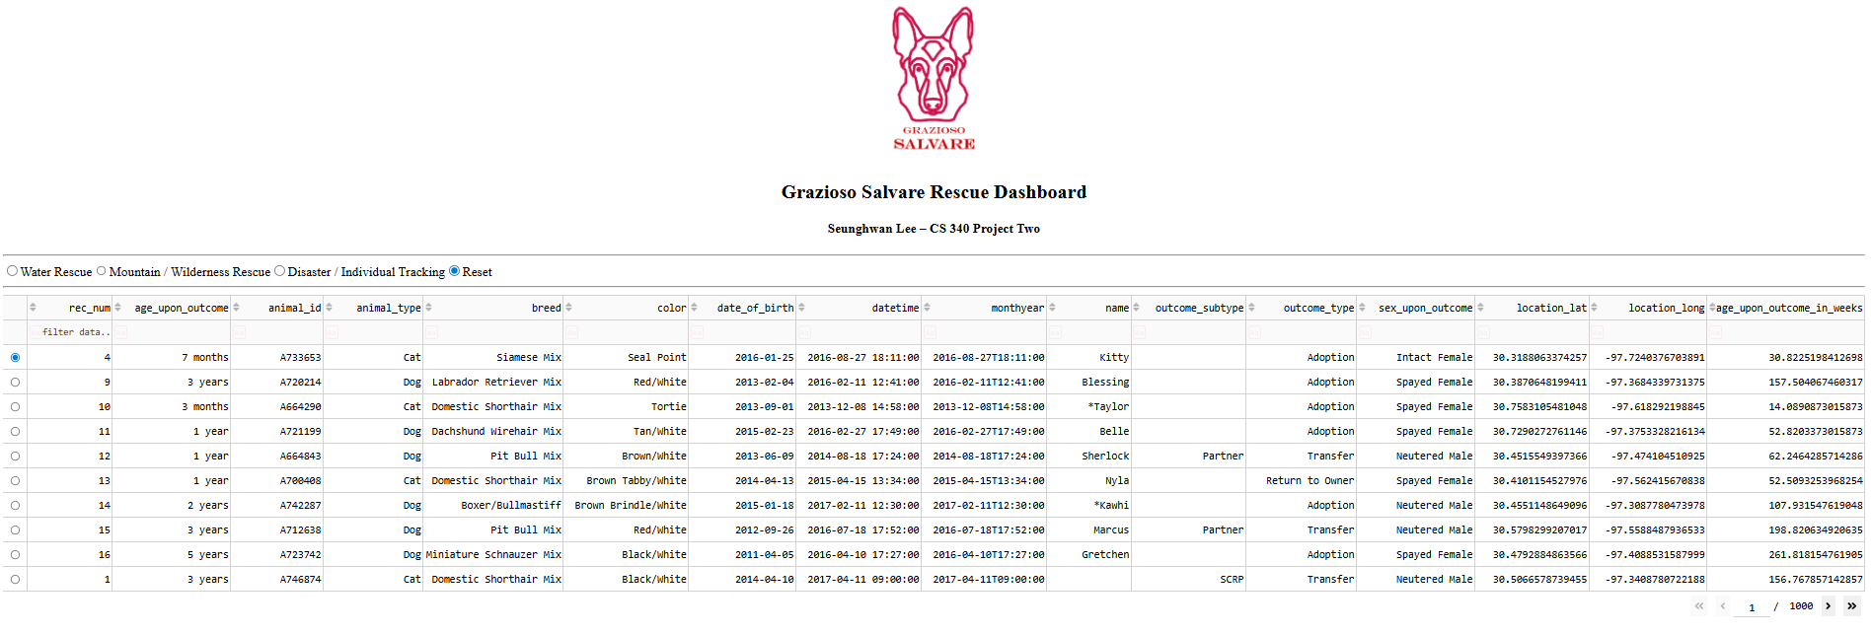
This screenshot shows the dashboard in its default state with the Reset filter selected. All animal records from the MongoDB database are displayed in the interactive data table.
The Grazioso Salvare logo and project identifier are visible at the top. The table supports sorting, pagination, and row selection. When a row is selected, the corresponding location is displayed on the map below.
This confirms that the database connection, CRUD read operation, and Dash callbacks are functioning correctly.
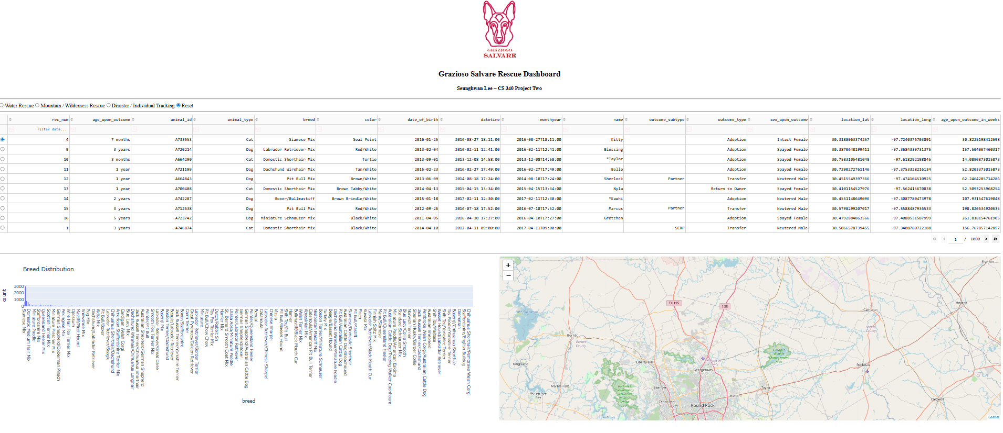
This screenshot shows the complete dashboard layout with the Reset filter applied. The data table displays all records from the database, while the Breed Distribution histogram reflects the full dataset.
The geolocation map is active and updates when a row is selected in the table. This confirms that all dashboard components—filters, table, chart, and map—are connected and functioning dynamically.
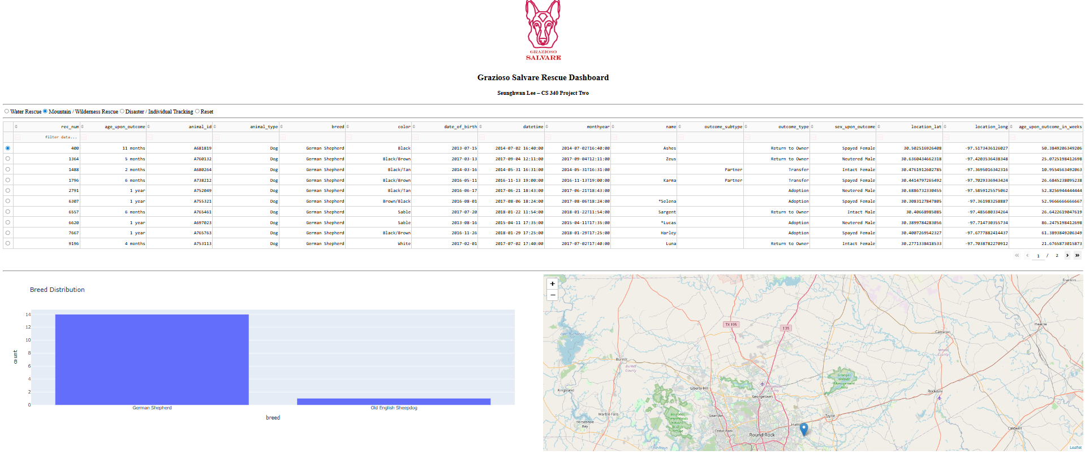
This screenshot shows the dashboard after selecting the Mountain / Wilderness Rescue filter. The data table now displays only qualifying breeds (such as German Shepherd and Old English Sheepdog) that meet the rescue criteria and age requirement.
The Breed Distribution chart updates to reflect only the filtered breeds, and the map displays the selected animal’s location. This confirms that the MongoDB query, filtering logic, and Dash callbacks are functioning correctly and updating all dashboard components dynamically.

Project Recreation
If this project needed to be recreated due to server migration or failed back up the following steps can be followed.
1. Install MongoDB and create the AAC database.
2. Import the Austin Animal Center Outcomes dataset into the animals collection.
3. Create the MongoDB user (aacuser) with appropriate authentication.
4. Install required Python dependencies.
5. Place the following files in the same directory:
- ProjectTwoDashboard.ipynb
- CRUD_Python_Module.py
- Grazioso Salvare Logo.png
6. Open ProjectTwoDashboard.ipynb in JupyterLab.
7. Execute all cells.
8. Confirm that:
- The data table loads.
- Filters function correctly.
- The histogram updates dynamically.
- The map displays selected animal locations.
The dashboard should launch locally on the default Dash port.

Pit Falls and Struggles
Several challenges were encountered during development:
1. MongoDB Authentication Errors
Initially, connection failures occurred due to incorrect authentication sources. This was resolved by specifying authSource=admin in the MongoDB URI.
2. DataTable and ObjectID Conflicts
MongoDB returns _id fields as ObjectID types, which caused DataTable rendering errors. This was resolved by excluding _id from query projections.
3. Callback Synchronization
Ensuring that filtering updates properly triggered both the data table and visualization components required careful callback design. This was solved by using Dash’s derived_virtual_data property.
4. Map Rendering Issues
Leaflet maps required careful handling of selected row indices to prevent NoneType errors when no row was selected.

These challenges strengthened understanding of MVC architecture, Dash callbacks, and MongoDB query construction.

Contact
Seunghwan Lee, created for SNHU CS-340 on 2/21/2026

Appendix

Dash callbacks
1. Rescue-Type Filtering Callback
The first callback connects the interactive radio button filter to the data table:
@app.callback(
Output('datatable-id', 'data'),
Input('filter-type', 'value')
)

When a user selects a rescue category (Water, Mountain/Wilderness, Disaster/Tracking, or Reset), the callback:
1. Builds a MongoDB query using predefined breed lists and an age limit (≤ 104 weeks).
2. Calls the read() method in the CRUD module.
3. Converts the results into a Pandas DataFrame.
4. Returns the filtered records to the DataTable.
5. This ensures that all displayed data meets Grazioso Salvare’s rescue training criteria.

2. Breed Distribution Visualization Callback
The second callback dynamically updates the breed distribution histogram:
@app.callback(
Output('graph-id', 'children'),
Input('datatable-id', 'derived_virtual_data')
)

This callback listens to changes in the DataTable. When filtering occurs:
The updated dataset is passed into the callback.
A Plotly histogram is generated based on breed frequency.
The visualization reflects the currently filtered data.
This approach ensures synchronization between the data table and the visualization layer.

3. Geolocation Map Callback
The third callback updates the Leaflet map:
@app.callback(
Output('map-id', 'children'),
[
Input('datatable-id', 'derived_virtual_data'),
Input('datatable-id', 'derived_virtual_selected_rows')
]
)

This callback performs the following steps:
Detects which row is selected in the data table.
Extracts latitude and longitude from the selected record.
Updates the map marker location.
Displays breed and animal name in a tooltip and popup.
This enables users to visually identify the location of selected animals, supporting spatial awareness for rescue coordination.

